**MCQ:**

1.Recursion is a method in which solution of a problem depends on ______________  
 a.Larger instances of different problem  
 b.Larger instances of same problem  
 c.Smaller instances of different problem  
 d.Smaller instances of same problem  
Ans - d. Smaller instances of different problem

2.Which of the following we can’t solve using recursion?  
 a.Factorial of a number  
 b.Length of a string  
 c.Nth fibonacci number  
 d.Problems without base case.  
Ans - d. Problems without base case.

3.In recursion, the condition for which the function will stop calling itself __________?  
 a.Base case  
 b.Worst case  
 c.Best case  
 d.There is no such condition  
Ans - a.Base Case

4.Consider the recursive function recur(n, k). You need to find the value of recur(4,3).  
Pseudocode:-

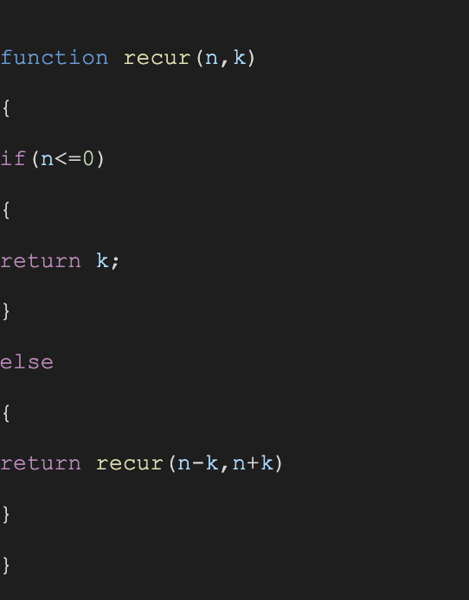  
 a.13  
 b.8  
 c.10  
 d.12

Ans - b.8  
  
5.The data structure used to implement recursive function calls ____________  
a.Array  
b.Binary tree  
c.Linked list  
d.Stacks

Ans - d.Stacks